CALL FOR SUBMISSIONS:
Community engagement for inclusive rural transformation and gender equality
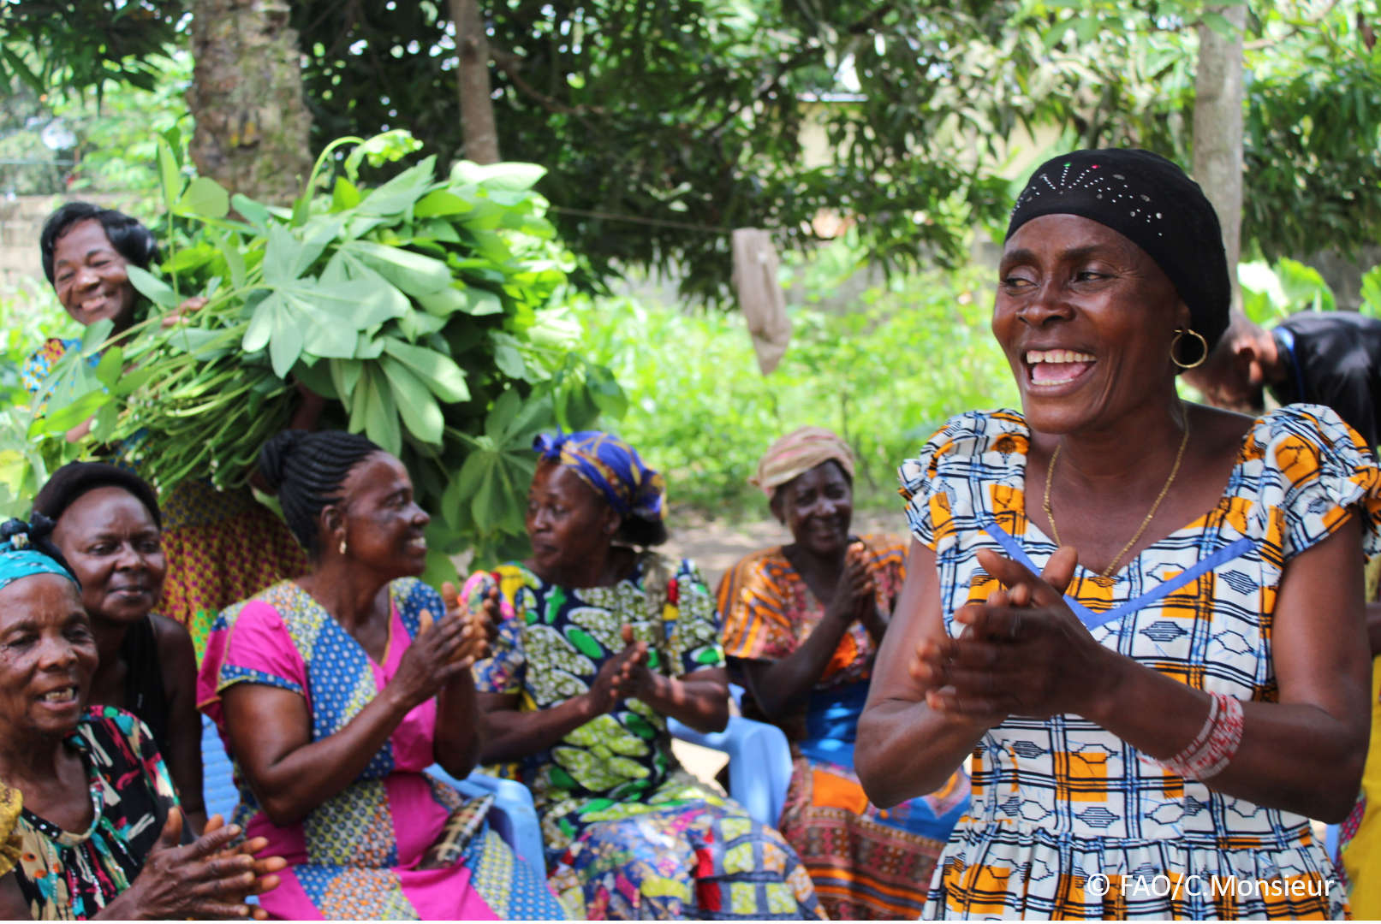
The objective of this call for submissions is to collect good practices, experiences, and lessons learnt on the use of community engagement for inclusive rural transformation and gender equality. The initiative, organized by the Rural Transformation and Gender Equality Division (ESP), seeks to gather insights from a diverse range of contributors, both within FAO and from external stakeholders. Its goal is to share knowledge, foster learning, and guide the scaling up of community engagement and community-led collective action to leave no one behind. The call builds on FAO's past efforts in this area, such as the Community Engagement Days series of webinars.
The call for submissions is open until 27 November 2024.

How to take part in this call for submissions:
To take part in this Call for submissions, please register to the FSN Forum, if you are not yet a member, or “sign in” to your account. Please review the topic note to understand the criteria we are considering for this call. If you wish to learn more about community engagement, you may refer to the background document. Once you have completed this submission template, upload it in the box “Post your contribution” on the call webpage, or, alternatively, send it to fsn-moderator@fao.org.
Please keep the length of submissions limited to 1,500 words and feel also free to attach relevant supporting materials.

Template for submissions

Contact person | Name: Isnawati Hidayah  Organization/Unit: ROTASI Institute (Institute for Rural Development and Sustainability)  Country: Indonesia  Email address: isnawati.hidayah@rotasi.or.id  Team: M. Syamsu Rizaludin & Prof Imam Mukhlis
Name/title of the good practice | Bridging Science, Innovation and Digitalization for a Transformative Agrifood System
Where is the good practice taking place? (Multiple selection allowed) | ☐ Europe and Central Asia  ☐ Latin America and the Caribbean  ☐ North Africa and Near East  ☐ Sub-Saharan Africa  ☒ Asia and the Pacific  ☐ North America  ☐ Global
Affiliation | ☐ Farmer and producer organizations  ☐ Trade Union  ☐ Informal community-based, farmer-based or self-help group  ☐ Research and academia  ☐ Government  ☐ Local/traditional authorities  ☐ Private Sector  ☒ Civil Society Organization  ☐ Intergovernmental Organization (e.g. UN system, World Bank)  ☐ Resource Partner/Donor  ☐ Other (please specify)
In which sector(s) and context (s) have you used this community engagement good practice? (Multiple selections allowed) | ☒ Education  ☐ Health and Sanitation  ☐ Food production in agrifood systems (please also tick the sub-categories)  ☐ Crop cultivation  ☐ Fisheries and aquaculture production  ☐ Livestock  ☐ Forestry  ☐ Agroforestry  ☐ Horticulture  ☐ Apiculture (beekeeping)  ☒ Agroecology and sustainable farming practices  ☒ Soil and water management  ☐ Other: ____________  ☐ Post-production in agrifood systems (please also tick the sub-categories)  ☐ Processing and value addition  ☐ Marketing and retailing  ☐ Transporting  ☐ Food loss and waste  ☐ Packaging  ☐ Storage  ☐ Distribution  ☐ Other _________  ☒ Gender Equality  ☐ Climate Action  ☐ Citizenship and Governance  ☒ Social Protection  ☐ Humanitarian and protracted crisis  ☐ Conflict resolution, peace and resilience  ☒ Digital innovation  ☐ Other sector (please specify) _________
Who are the financial partners supporting this good practice, if applicable?
- In a few sentences, summarize your community engagement good practice.
Our organization is dedicated to addressing rural development and sustainable agricultural economics in Indonesia through research, community engagement, and collaboration with diverse stakeholders. One of the critical challenges we tackle is the vulnerability of food and nutrition security, exacerbated during the COVID-19 pandemic. A strategic solution we advocate is enhancing food security in Indonesia by implementing smart climate agriculture systems in rural areas.

We focus on developing marginalized regions and empowering underprivileged communities. Our programs emphasize establishing agroecological and soil-less farming practices rooted in a circular economy to bolster community food security. Our flagship project is based in East Java, Indonesia, with plans for expansion to other villages, leveraging multidisciplinary expertise.

A key strength of our initiatives is the active involvement of youth in empowerment activities, conducted in collaboration with universities. Our program implementations are supported by rigorous research, with findings disseminated through reputable scientific journals. These publications aim to provide learning tools and actionable recommendations for other communities.

The circular agriculture model we promote engages all stakeholders in managing household and agricultural waste, transforming it into compost for farming. With lab testing and expert guidance from the ROTASI team, this compost can be refined into a signature product for the village, fostering local sustainability and economic growth.
- What problem(s) or challenge(s) does your good practice aim to address through community engagement?

The funding availability.
- Describe your good practice in more detail. Include the main guiding principles, the desired changes or outcomes you aim to achieve (Theory of Change), and the key phases of implementation.

Guiding Principles
Our approach emphasizes eco-friendly, participatory methods to promote sustainable agriculture and circular economy principles. Recognizing the limited knowledge of communities in managing land and producing food using available resources, the ROTASI Institute facilitates knowledge transfer and practical training. By engaging diverse stakeholders, including local youth groups (karang taruna), universities, NGOs, and private sector partners, we ensure inclusivity and long-term sustainability in addressing food and nutrition security challenges.
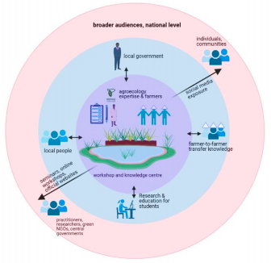
Theory of Change
Our Theory of Change is rooted in empowering communities to adopt sustainable agricultural practices that improve food security and resilience to climate variability. We aim to transform rural areas into knowledge hubs for agroecology, fostering collaborations between researchers and communities.

1. Short-Term Goals:
- Equip villages with sustainable agricultural systems integrating local wisdom.
- Train communities in farming practices, composting.
- Promote stakeholder collaboration to align efforts.

2. Medium-Term Goals:
- Increase public awareness of agroecology, soil-less farming and food security through campaigns and workshops.
- Enhance community participation in environmentally friendly practices.

3. Long-Term Goals:
- Establish “Sustainable Agriculture and Knowledge Centers” as research and learning hubs.
- Facilitate collaborations between international and local researchers to innovate agroecological practices.
- Promote circular economy-based systems for community-driven, climate-resilient agriculture.

Key Phases of Implementation

1. Preparation and Stakeholder Engagement:
- Networking: Leverage partnerships with local organizations, government representatives, universities, and NGOs.
- Team Allocation: Assign ROTASI Institute members to roles based on expertise and establish clear communication channels.
- Timeline and Goals: Develop a structured implementation and evaluation timeline.

2. Capacity Building and Training:
- Collaborate with Universitas Negeri Malang and local organizations to implement programs.
- Involve university students as interns for field activities, enhancing community engagement.
- Conduct training sessions on rainwater harvesting, agroecological farming, composting, business modeling, and post-harvest product promotion.

3. Program Implementation:
- Launch on-farm workshops and knowledge centers in Malang (East Java) and Sukabumi (West Java).
- Facilitate experience-sharing between agroecological farmers and conventional farmers.
- Provide science-based insights on enhancing crop productivity and resilience.

4. Knowledge Dissemination:
- Document activities and share them on social media and our official website (www.rotasi.or.id).
- Produce a short documentary featuring farmer and expert testimonies to broaden outreach.

5. Scaling and Evaluation:
- Design a blueprint to expand the program nationally.
- Monitor and evaluate outcomes to refine the approach and ensure sustainability.

By combining participatory training with rigorous research and stakeholder collaboration, our program promotes sustainable agriculture as a viable solution for improving food security and building climate resilience in Indonesia. Through these initiatives, we aim to inspire and empower communities, creating scalable models for national and international application.

- Who are the key actors and stakeholders involved in the design and implementation of the good practice, and what are their respective roles? Consider local partners, government, local authorities, community radios, civil society, research, the private sector, etc.
The community's understanding of managing their land using circular economy principles and sustainable agriculture is still limited, particularly when it comes to producing everyday food from available resources. Our approach emphasizes eco-friendly methods that prioritize active community involvement. The ROTASI Institute plays a key role in supporting the community through knowledge sharing and hands-on training. We also collaborate with various stakeholders, including local youth, to ensure the success of our program. These stakeholders include universities, private sector partners, and local youth organizations (such as Karang Taruna). Our campaign targets several audiences, such as community farmers (including young farmers), local residents, and high school and college students near our workshops and knowledge centers. Additionally, we aim to reach people beyond these centers, both nationally and internationally. In addition to the workshops and social media campaigns, we plan to host an online mini-seminar featuring agroecology experts from the Netherlands. This collaboration is made possible through the network of Rotasi Institute members, many of whom studied at Wageningen University & Research in the Netherlands. Through this campaign, we hope to increase the adoption of agroecology among local farmers near our workshop sites. Furthermore, we aim to raise awareness both locally and globally about sustainable agricultural systems that are better suited to climate change and contribute to protecting the planet from further environmental degradation.

- How does your intervention ensure inclusivity and equal and meaningful participation within the community?
We prioritize inclusivity and ensure equal, meaningful participation by engaging a diverse range of groups. To achieve this, we will adopt tailored approaches and design specific events that cater to the unique needs and interests of different community segments. This will ensure that their presence is recognized, valued, and highlighted throughout our initiatives.
- By using community engagement, what results and impacts have your good practice achieved?
Our program provides a platform that empowers young people and local residents to actively participate in the development of their own community. To date, we have positively impacted over 50 village residents and engaged more than 10,000 young people through a variety of educational activities, both online and offline.
- Among these results, has the good practice led to improvements in terms of gender equality, women’s empowerment, and/or social inclusion?
We invite women to participate in this initiative, providing them with knowledge on how to grow their own home gardens and teach their children the importance of healthy eating.
- What key challenges did you encounter while implementing the community engagement activities, and how did you address them?
Before launching any program, we conduct Focus Group Discussions (FGDs) to actively listen to the local community's perspectives. This process allows us to ensure that our innovations align with their values, cultural norms, and are socially acceptable. By engaging directly with the community, we can adapt our approach to better meet their needs and ensure that our initiatives are both relevant and respectful of local traditions. This collaborative approach helps build trust and ensures the success and sustainability of our programs.
- What are the key lesson learned from your community engagement good practice?
We tailor our programs to the specific context and needs of the community, ensuring they are relevant to their unique conditions. We prioritize ongoing, open communication, fostering trust and collaboration with local residents. Additionally, we are committed to respecting local cultural norms and beliefs, ensuring that our approach is both sensitive and inclusive. This respectful engagement helps us build stronger relationships and ensures that our initiatives are embraced by the community.
- Has this practice been replicated in the same context or in different contexts?
What are the required conditions to replicate and adapt the practice in another context/geographical area?
Yes, in the same context
- How sustainable are the results achieved by this good practice?
To ensure the long-term sustainability of our initiative, several key elements must be in place:

1. Enabling Environment : We work to create a supportive legal and policy framework that encourages sustainable practices. This includes aligning with local regulations, engaging with relevant institutions, and advocating for policies that support our goals. A clear legal structure not only facilitates smooth operations but also ensures that our work is recognized and supported by local authorities.
2. Local Ownership : Central to the sustainability of our initiative is fostering local ownership. We empower community members by involving them at every stage, from planning to implementation. This ensures that they feel a sense of responsibility for the project’s success and are motivated to continue its work beyond the initial phase.

3. Legal Recognition : To further ensure autonomy and long-term viability, we help establish a local team and formally register them as a legal entity under Indonesia’s Ministry of Law. This legal recognition allows them to operate independently, access resources, and seek funding from various sources, enabling them to stand on their own feet.

4. Accountability and Transparency : We establish clear structures for accountability, ensuring that all stakeholders are responsible for their roles and that resources are managed transparently. Regular monitoring and evaluation processes are put in place to assess progress, identify challenges, and adapt strategies as needed.

5. Financial Sustainability : We work closely with the local team to build their capacity in fundraising, financial management, and resource mobilization. This ensures that they are not reliant on external funding sources but are able to generate their own income and sustain their operations in the long term.
By embedding these key elements—legal and institutional support, local ownership, accountability, and financial independence—into the foundation of our initiative, we ensure its continued success and sustainability.
- Based on the conversations FAO held during the Community Engagement days, a definition of community engagement for empowerment was proposed:

“Community engagement for empowerment and community-led collective action can be defined as an inclusive and participatory process that enables community members to become active agents of change in decisions affecting their lives, health, and environment. This process develops their capacity to achieve sustainable outcomes for improved rural livelihoods. Embracing a rights-based approach, it prioritizes the agency and participation of all community members, regardless of gender identity, sexual orientation, age, ethnicity, caste, socioeconomic status, political affiliation, migration status, or ability/disability. Indeed, inclusive approaches recognize the complexities of overlapping marginalization and discrimination that can exclude different community members from decision-making processes and implement strategies to foster their participation, agency and empowerment.”

We invite you to contribute to this definition. What would you add or change? Please share your thoughts, suggestions, and any additional elements you believe are crucial for a comprehensive understanding of community engagement approaches aimed at community-led collective action for inclusive rural transformation, people’s empowerment and gender equality.

Suggestion:
Embracing a rights-based approach, it prioritizes the agency and active participation of all community members—irrespective of gender identity, sexual orientation, age, ethnicity, caste, socioeconomic status, political affiliation, migration status, beliefs, or ability/disability. Additionally, it adopts an inclusive approach that recognizes and respects the unique needs, rights, and contributions of Indigenous groups.

- Based on your experience, what gaps or areas for improvement still need to be addressed in the field of community engagement?
A crucial aspect of our approach is understanding the genuine needs of the local community and ensuring that our interventions are aligned with their values and traditions. It’s essential that we respect and integrate local wisdom and cultural practices into our programs, so that our work feels relevant and respectful to the community.

One of the greatest challenges we face is ensuring the sustainability of our programs even after we have transitioned out. To address this, we involve the community at every stage of the process—from planning and design to implementation and evaluation. By actively engaging community members, we help foster a deep sense of ownership and belonging. This involvement ensures that the community feels responsible for carrying forward what has been established, and that the programs continue to thrive independently.

Ultimately, when the local community is fully engaged, they are more likely to maintain and adapt the programs in ways that meet their evolving needs. This sense of shared purpose not only enhances the impact of our initiatives but also strengthens the community’s ability to sustain the changes long after we are no longer directly involved.
- What do you think is FAO's role in the field of community engagement? How can FAO support and enhance interventions like yours, if applicable?

We require support in several critical areas to strengthen and sustain our efforts:

- Policy Advocacy : Assistance in advocating for policies that promote sustainability, equity, and community empowerment is essential for creating an enabling environment that supports our goals.

- Capacity Development : We seek support for building the skills and capabilities of local communities and partners, ensuring they are equipped to implement and sustain impactful programs on their own.

- Funding : Adequate financial resources are crucial for scaling our initiatives and ensuring their long-term viability. Support in securing funding will allow us to expand our reach and impact.

- Technical Assistance : Access to expert guidance and technical support is necessary to implement effective, innovative solutions in agriculture, sustainability, and community development.

- Knowledge Production and Sharing : We need help in generating, documenting, and disseminating valuable knowledge and insights, both to improve our own practices and to share learnings with others in the field.

- Fostering Partnerships : Building strong, collaborative partnerships with local organizations, government agencies, universities, and the private sector will enhance our capacity to achieve sustainable, scalable outcomes.

With support across these areas, we can amplify the impact of our work, drive meaningful change, and ensure long-term success.
Link(s) to specific references about your good practice (e.g. reports, communication products, videos, articles)

- https://drive.google.com/file/d/1CtGIYUVrHSm6DVg53nSuAfXg4XXs4otI/view?usp=share_link
- https://youtu.be/iAA91J82NGM
- https://youtu.be/NRwM6n0eqi0
- https://youtu.be/EY88msiSrKQ
- https://youtu.be/Yk5wJx9jWBY
- http://rotasi.or.id/
- https://www.instagram.com/rotasi.institute/
- https://id.linkedin.com/in/rotasi-institute-1a5200220

The call for submissions is directly aligned with the thematic components of collective action within FAO's Programme Priority Areas (PPAs), specifically Better Life 1 (Gender Equality and Rural Women’s Empowerment), Better Life 2 (Inclusive Rural Transformation) and Better Life 3 (Agriculture and Food Emergencies).

